Assignment
Fundamental Theory
(LAB: 6)
NAME: Majid Ali
CMS ID: 053-25-0017
PROGRAM: Software engineering (Section: A)

Question 1:
Write a C++ program that should ask a user to input an integer number and then displays/prints its table as shown below:
#include <iostream>
using namespace std;
int main(){
int table_number;
cout<<"Enter the table number: ";
cin>>table_number;
for(int i =1;i<=10; i++){
cout<<table_number<<"X"<<i<<"="<<table_number*i<<endl;
}
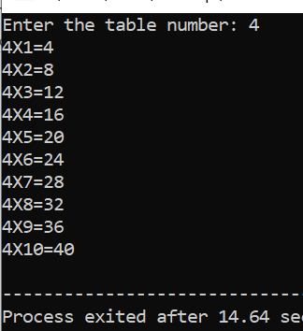
return 0;
}

Question 2:
Write a program that ask user to input the start and the End of the series. Then it prints whole, natural, Even and odd numbers between these ranges. Let’s suppose the user enters value 4 for start, and value 12 for start End. Then the output of the program:
#include <iostream>
using namespace std;
int main(){
int i;
int start,end;
cout<<"Enter the starting number: ";
cin>>start;
cout<<"Enter the ending number: ";
cin>>end;
cout<<"Natural number:";
for(i=start;i<=end; i++){
if(i>=1){
cout<<" "<<i;}
}
cout<<endl;
cout<<"whole number:";
for(i=start;i<=end; i++){
if(i>=0){
cout<<" "<<i;}
}
cout<<endl;
cout<<"Even number:";
for(i=start;i<=end; i++){
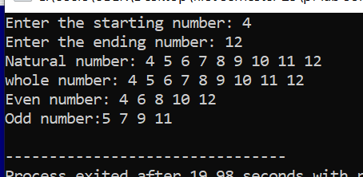
if(i%2==0){
cout<<" "<<i;
}
}
cout<<endl;
cout<<"Odd number:";
for(i=start;i<=end; i++){
if(i%2!=0){
cout<<i<<" "; }
}
cout<<endl;
return 0;
}
Question 3:
Write a program that ask user to input the start and the End of the series. Then it prints whole, natural, Even and odd numbers between these ranges but in reverse order. Let’s suppose the user enters value 0 for start, and value 10 for start End. Then the output of the program:
#include <iostream>
using namespace std;
int main(){
int i;
int start,end;
cout<<"Enter the starting number: ";
cin>>start;
cout<<"Enter the ending number: ";
cin>>end;
cout<<"Natural number:";
for(i=end;i>=start; i--){
if(i>=1){
cout<<i<<" ";}
}

cout<<endl;
cout<<"whole number:";
for(i=end; i>=start; i--){
if(i>=0){
cout<<" "<<i;}
}
cout<<endl;
cout<<"Even number:";
for(i=end;i>=start; i--){
if(i%2==0){
cout<<" "<<i;
}
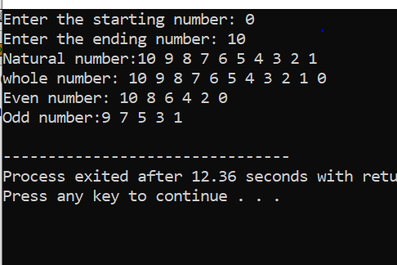
}
cout<<endl;
cout<<"Odd number:";
for(i=end;i>=start; i--){
if(i%2!=0){
cout<<i<<" "; }
}
cout<<endl;
return 0;
}

Question 4:
Write a C++ program that should ask the user to input the final range up to which the loop should run and then prints ONLY the multiples of 5 (fully divided by 5 only), as
#include <iostream>
using namespace std;
int main(){
int i;
int range;
cout<<"Enter the range upto which loop the run: ";
cin>>range;
for(int i=5; i<=range; i+=5){
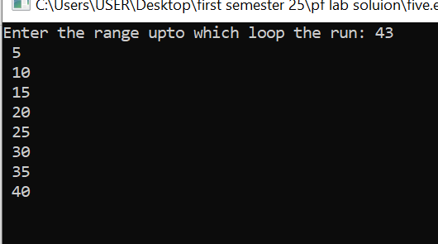
cout<<" "<<i;
cout<<endl;
}
cout<<endl;
return 0;
}

Question 5:
Write program using a for loop to print a series of 10 numbers as shown below:
#include <iostream>
using namespace std;
int main(){
int i;
int range,previous=0;
cout<<"Enter the range upto which loop the run: ";
cin>>range;
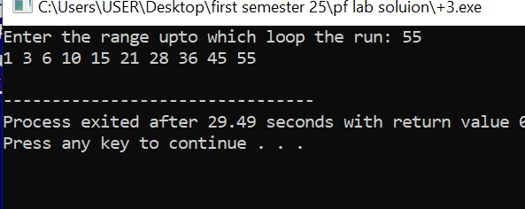
for(int i=1; i<=range; i++){
previous+=i;
if(previous>55){
break;
}
cout<<previous<<" ";
}
cout<<endl;
return 0;
}

Question 6:
Write a C++ program that asks a user to input the range (final value) up to which the loop should run and then for each number in that range, it should tell whether that (each) number is Odd or Even. For example, if the user enters 7 as the final value of the range, then it should display like following:
#include <iostream>
using namespace std;
int main(){
int i;
int range;
cout<<"Enter the range upto which loop the run: ";
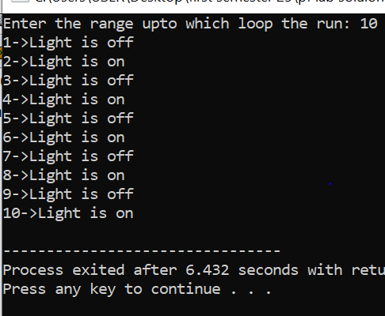
cin>>range;
for(int i=1; i<=range; i++){
cout<<i;
if(i%2==0){
cout<<"->Light is on";}
else {
cout<<"->Light is off";
}
cout<<endl;
}

Question 7:
Using loop, write a C++ program that displays a series of alphabets in ascending order from ‘A’ to ‘Z’ and then in descending order from ‘Z’ to ‘A’.
#include <iostream>
using namespace std;

int main()
for (char ch = 'A'; ch <= 'Z'; ++ch) {
cout << ch << " ";
}
cout << endl;

// Descending order from Z to A
for (char ch = 'Z'; ch >= 'A'; --ch) {
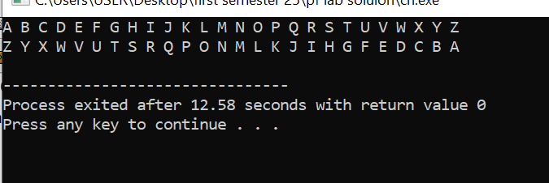
cout << ch << " ";
}
cout << endl;

return 0;
}

Question 8:
#include <iostream>
using namespace std;
int main(){
char ch1,ch2;
cout<<"Entr the starting character: ";
cin>>ch1;
cout<<"Entr the ending character: ";
cin>>ch2;
cout<<"consonant are from: "<<ch1<<" to"<<ch2<<": "<<endl;
for(char i=ch1; i<=ch2; i++){
if (i != 'a' && i != 'e' && i != 'i' && i != 'o' && i != 'u' &&
i != 'A' && i != 'E' && i != 'I' && i != 'O' && i != 'U') {
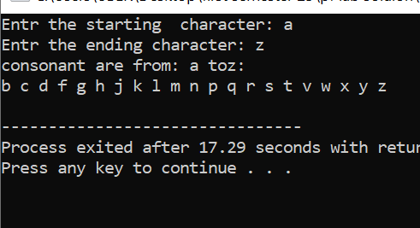
cout<<i<< " ";}

}
cout<<endl;
return 0;
}

Question 9:
The Fibonacci sequence is a series where the next term is the sum of the previous two terms. The first two terms of the Fibonacci sequence are 0 and 1. The series is as follows: 0, 1, 1, 2, 3, 5, 8, 13, 21, 34, … Write a C++ program (using loop) to print the 10 numbers of the Fibonacci series as shown above.
#include <iostream>
using namespace std;
int main() {
int n = 10;
int first=0, second=1,next;
cout << "Fibonacci series up to "<<n<<"terms:"<<endl;
cout<<first<< ", "<<second;
for (int i=3; i<=n; i++) {
next=first+second;
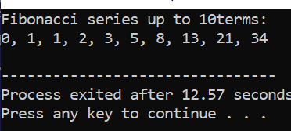
cout<< ", " <<next;
first=second;
second=next;
}
cout<<endl;
return 0;
}
Question 10:
Write a program to ask the user to input n_courses (Total Courses), then iterate loop n_courses time and ask user marks in each course and perform the following tasks: a) Make sure n_courses is between (3 to 8) b) Calculate the average of all course marks. c) Calculate the total percentage of all courses. d) Tell the user whether she/he is PASS/FAIL, FAIL → less than 60, and otherwise PASS.
#include <iostream>
using namespace std;
int main(){
int marks,sum=0;
float average,Total_percentage;
cout<<"Enter the number of courses between (3 and 8): "<<endl;
for(int i=1; i<=4; i++){
cout<<"Enter the marks for courses "<<i<<":";
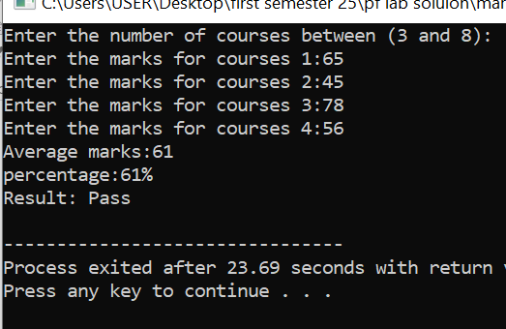
cin>>marks;
sum+=marks;
}
average=(float)sum/4;
cout<<"Average marks:"<<average<<endl;
Total_percentage=(float)sum/400*100;
cout<<"percentage:"<<Total_percentage<<"%"<<endl;
if(Total_percentage<60){
cout<<"Result: Fail"<<endl;
}
else{
cout<<"Result: Pass"<<endl;
}
return 0;
}

Question 11:
Write a program to output the N terms of HARMONIC series and their SUM.
#include <iostream>
using namespace std;
int main() {
int n;
float sum=0.0;
cout<<"Enter the number of terms: ";
cin>>n;
cout <<"Harmonic Series: ";
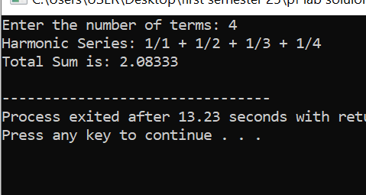
for (int i = 1; i <= n; i++) {
cout<<"1/"<< i;
if (i<n)
cout << " + ";
sum+=1.0/i;
}
cout<<endl;
cout<<"Total Sum is: "<<sum<<endl;
return 0;
}

Question 12:
2. Write a program to output the N terms of HARMONIC series and their SUM.
#include <iostream>
using namespace std;
int main() {
int n;
float sum = 0.0;

cout<< "Enter the number of terms: ";
cin>>n;

cout<<"Harmonic Series: ";
for (int i =1; i <=n; i++) {
cout <<"1/"<< i;
if (i%2== 0) {
sum-=1.0/i;
if (i < n)
cout<<" - ";
} else {
sum+=1.0/i;
if (i<n)
cout<<"+";
}
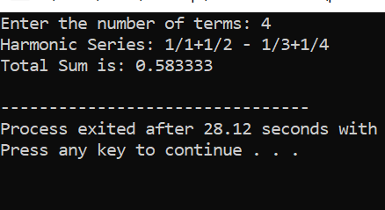
}

cout<<endl;
cout <<"Total Sum is: "<<sum<< endl;

return 0;
}

